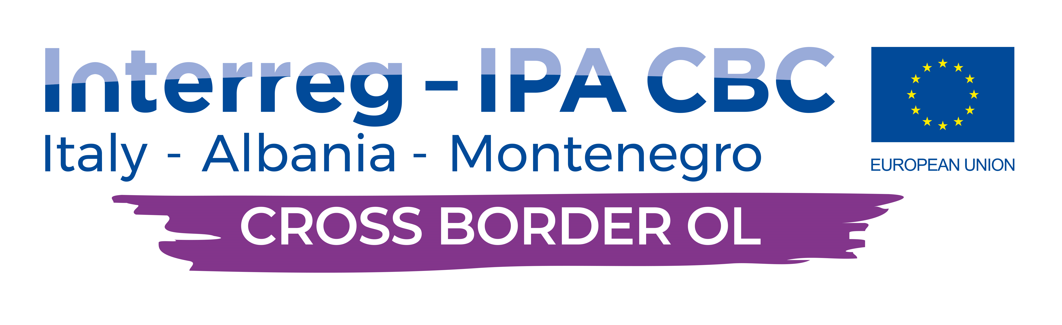
Cross-border cooperation for sustainable development and tourism, trough valorization of rural cultural heritage and conservation of natural asset of areas with ancient olive groves

CROSS BORDER OLIVE
3rd Steering Committee Meeting

3rd July 2019, Parco dell’Olivo di Venafro, Molise, Italy

MEETING AGENDA

Time | Presentation | Speaker | Location
9:00-9:15 | Registration of participants |  | Palace Hotel
9:15-9:40 | Welcome and introductory to the agenda and daily activities | Emilio Pesino  Olive Park of Venafro  Fatbardh Sallaku Project Coordinator AUT, LP
9:40 – 10:40 | Mapping Olive Trees, Grove, Best Practices and Census of AOOs | Consortium
10:40-11:10 | Coffee Break
11:10-12:00 | Issues related to the technical activities, methodology, stakeholder involvement, Workshops | Consortium
12:00-13:30 | List of the Stakeholders and Stakeholder Analysis from each partner | Consortium
13:30-15:00 | Lunch
15:00-15:45 | Discussion of the ongoing deliverable and Join Progress Report of the 3rd Period | Consortium
15:45-16:30 | Financial and administrative issues - Discussion  (3rd progress reports) | Prof. Dr. Endrit Kullaj  Dr. Romina Koto
16:30 | End of Steering Committee works for the 3rd July
17:50-19:15 | Press Conference | Consortium | Park Premises  Palazzina Liberty
19:20-20:30 | Aperitif and Olive Oil tasting |  | Park Area
21:00 | Partnership Dinner |  | Dimora del Prete

4th July 2019, Parco dell’Olivo di Venafro, Molise, Italy

Time | Presentation | Speaker | Location
9:00-9:10 | Registration of participants |  | Palace Hotel
9:10-9:30 | Issue on the 2st Progress Report outcomes. | Consortium
9:30-9:50 | Presentation of the timetable and operational procedures for the next period | Consortium
9:50-10:20 | Financial Issues of the project | Consortium
10:20-10:30 | Final discussion and upcoming events | Consortium
10:30-11:00 | Coffee break
11:00-12:00 | Steering Committee meeting | Consortium
12:00 | Farewell | Consortium

