MINUTES of MEETING
25th March 2021
CROSS BORDER Ol project closure 2021

1. Date and place of the event

The Closing Meeting for Albania of the CROSS BORDER Ol project took place in Tirana, Albania on the 25th of March 2021. The Event took place at the premises of the Agricultural University of Albania. Due to the restrictions imposed by the Albanian Government for the Pandemic caused by COVID19, the meeting took place outdoor. The meeting was organised as an hybrid event which part of the meeting were held physically at the AUT premises and the colleagues from CIHEAM Bari were connected online via ZOOM.

2. Participants

In the meeting were present project partners from UBT and URI as well as local community members from the three selected sites.
The colleagues from CIHEAM Bari were present in the meeting via ZOOM. Attendance list in Annex I.

3. Presentations

Erni Kocani from URI opened the meeting and made an introduction of the project and project partners and the main scope of the project.
Than Mr. Fatbardh Sallaku the Rector of AUT, as the lead partner representative made a short introduction of the project highlighting project outcomes but also difficulties during the implementation phase of the project. He also emphasized the importance of such projects for the promotion and sustainable development of rural areas in Albania but also in Italy and Montenegro.

After the word of Mr. Sallaku the technical presentations started with Mr. Adhurim Lazaj which presented the Best Practices for olive cultivation and maintenance in the 3 sites selected by the project, namely: Marikaj, Ndroq and Preza.

The meeting followed with the presentation of Mrs. Erdona Demiraj from AUT, which presented part of the Environmental Tourist and Economic Plan of the selected areas. The presentation was focused in presenting the historical background and the tradition of these communities in handcrafts and eno - gastro economic and the potential to attract more tourist in these areas.

After Mrs. Demiraj, Mr. Kocani from URI took the word in order to present the Environmental Tourist and Economic Plan of the selected areas focusing on the analysis of the territory made during the implementation phase of the project. He presented the strengths, opportunities that the community in collaboration with the local and national institutions could explore in order to achieve better environment, economic and social status of the area and its inhabitants.

The meeting than continued with the presentation by Mr. Gianfranco Ciola, CIHEAM which presented The SMART and Sustainable Cross-Border Tourism Plan for Ancient Olive Groves in Albania Montenegro and Molise. Mr. Ciola presented the findings from the studies made in Albania, Montenegro and Italy and the similarities and differences that these countries have regarding the practices of olive cultivation and maintaining, he also presented opportunities for the development of these areas in order to increase the tourist attentions regarding ancient alive groves and rural landscapes.

The moderator than give the word to Mr. Afrim Ozuni representative from the Administrative Unit of Ndroq, Municipality of Tirana, which highlight the need to focus more on the rural areas a in order to achieve a good level of sustainable development. He also stated that further projects fot the promotion of rural tourism and economic are welcomed.

Mr. Pandeli Pasko, CIHEAM Bari Project Coordinator, delivered the closing speech in which he described all the stages of the project as well as his achievements by emphasizing the opportunities for other co-operation to promote tourism of these areas. He also thanked project partners from Ente Parco Regionale Storico Agricolo Dell’olivo Di Venafro, Italy, Municipality of Bar, and Association for Sustainable Regional Olive Farming – VALDANOS, Montenegro.

Annex I

Agenda of the meeting
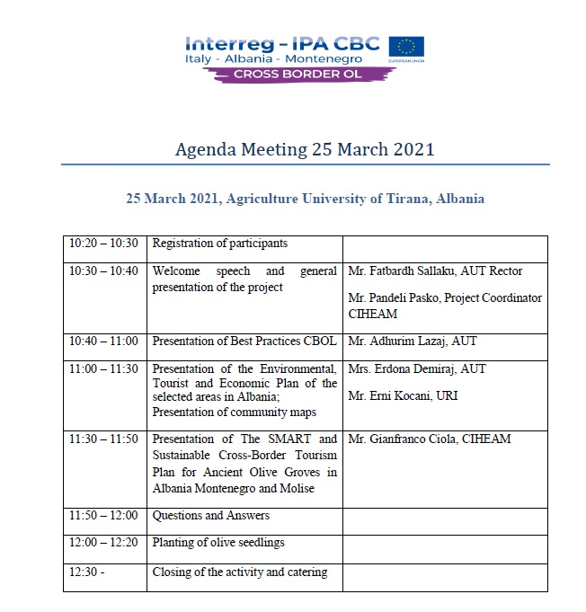

Attendance list

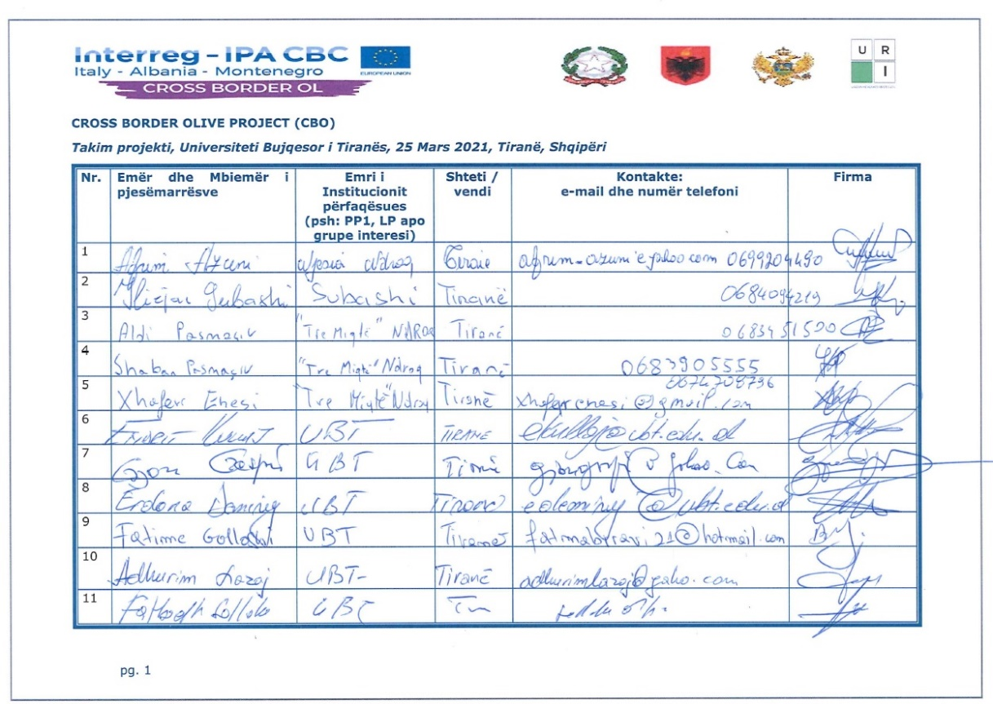

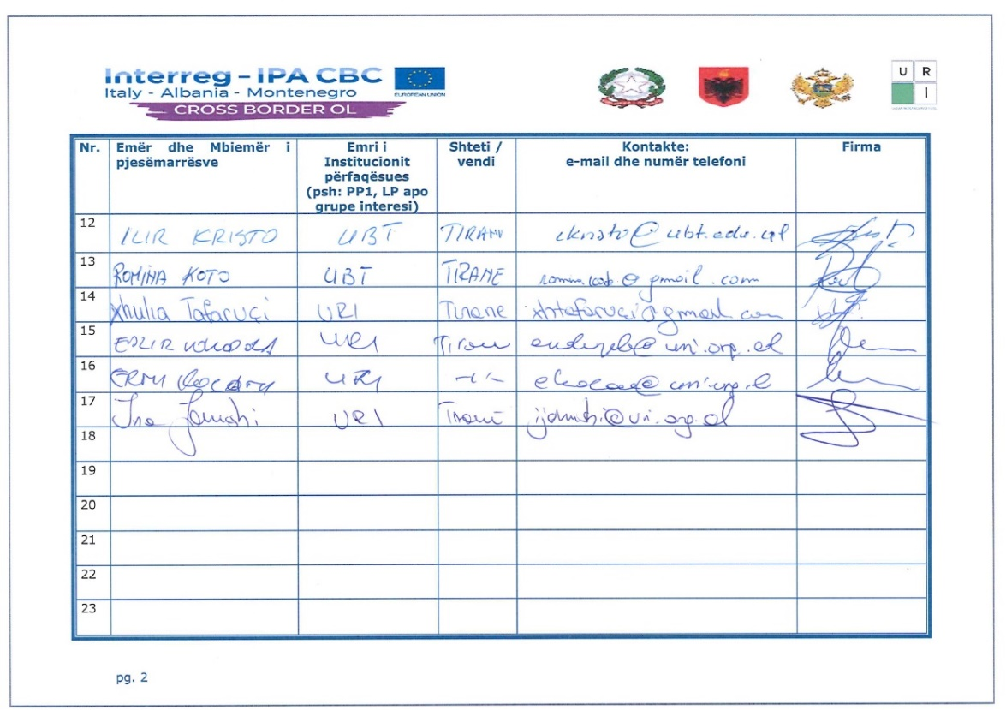

Photos of the meeting
